Supplementary materials

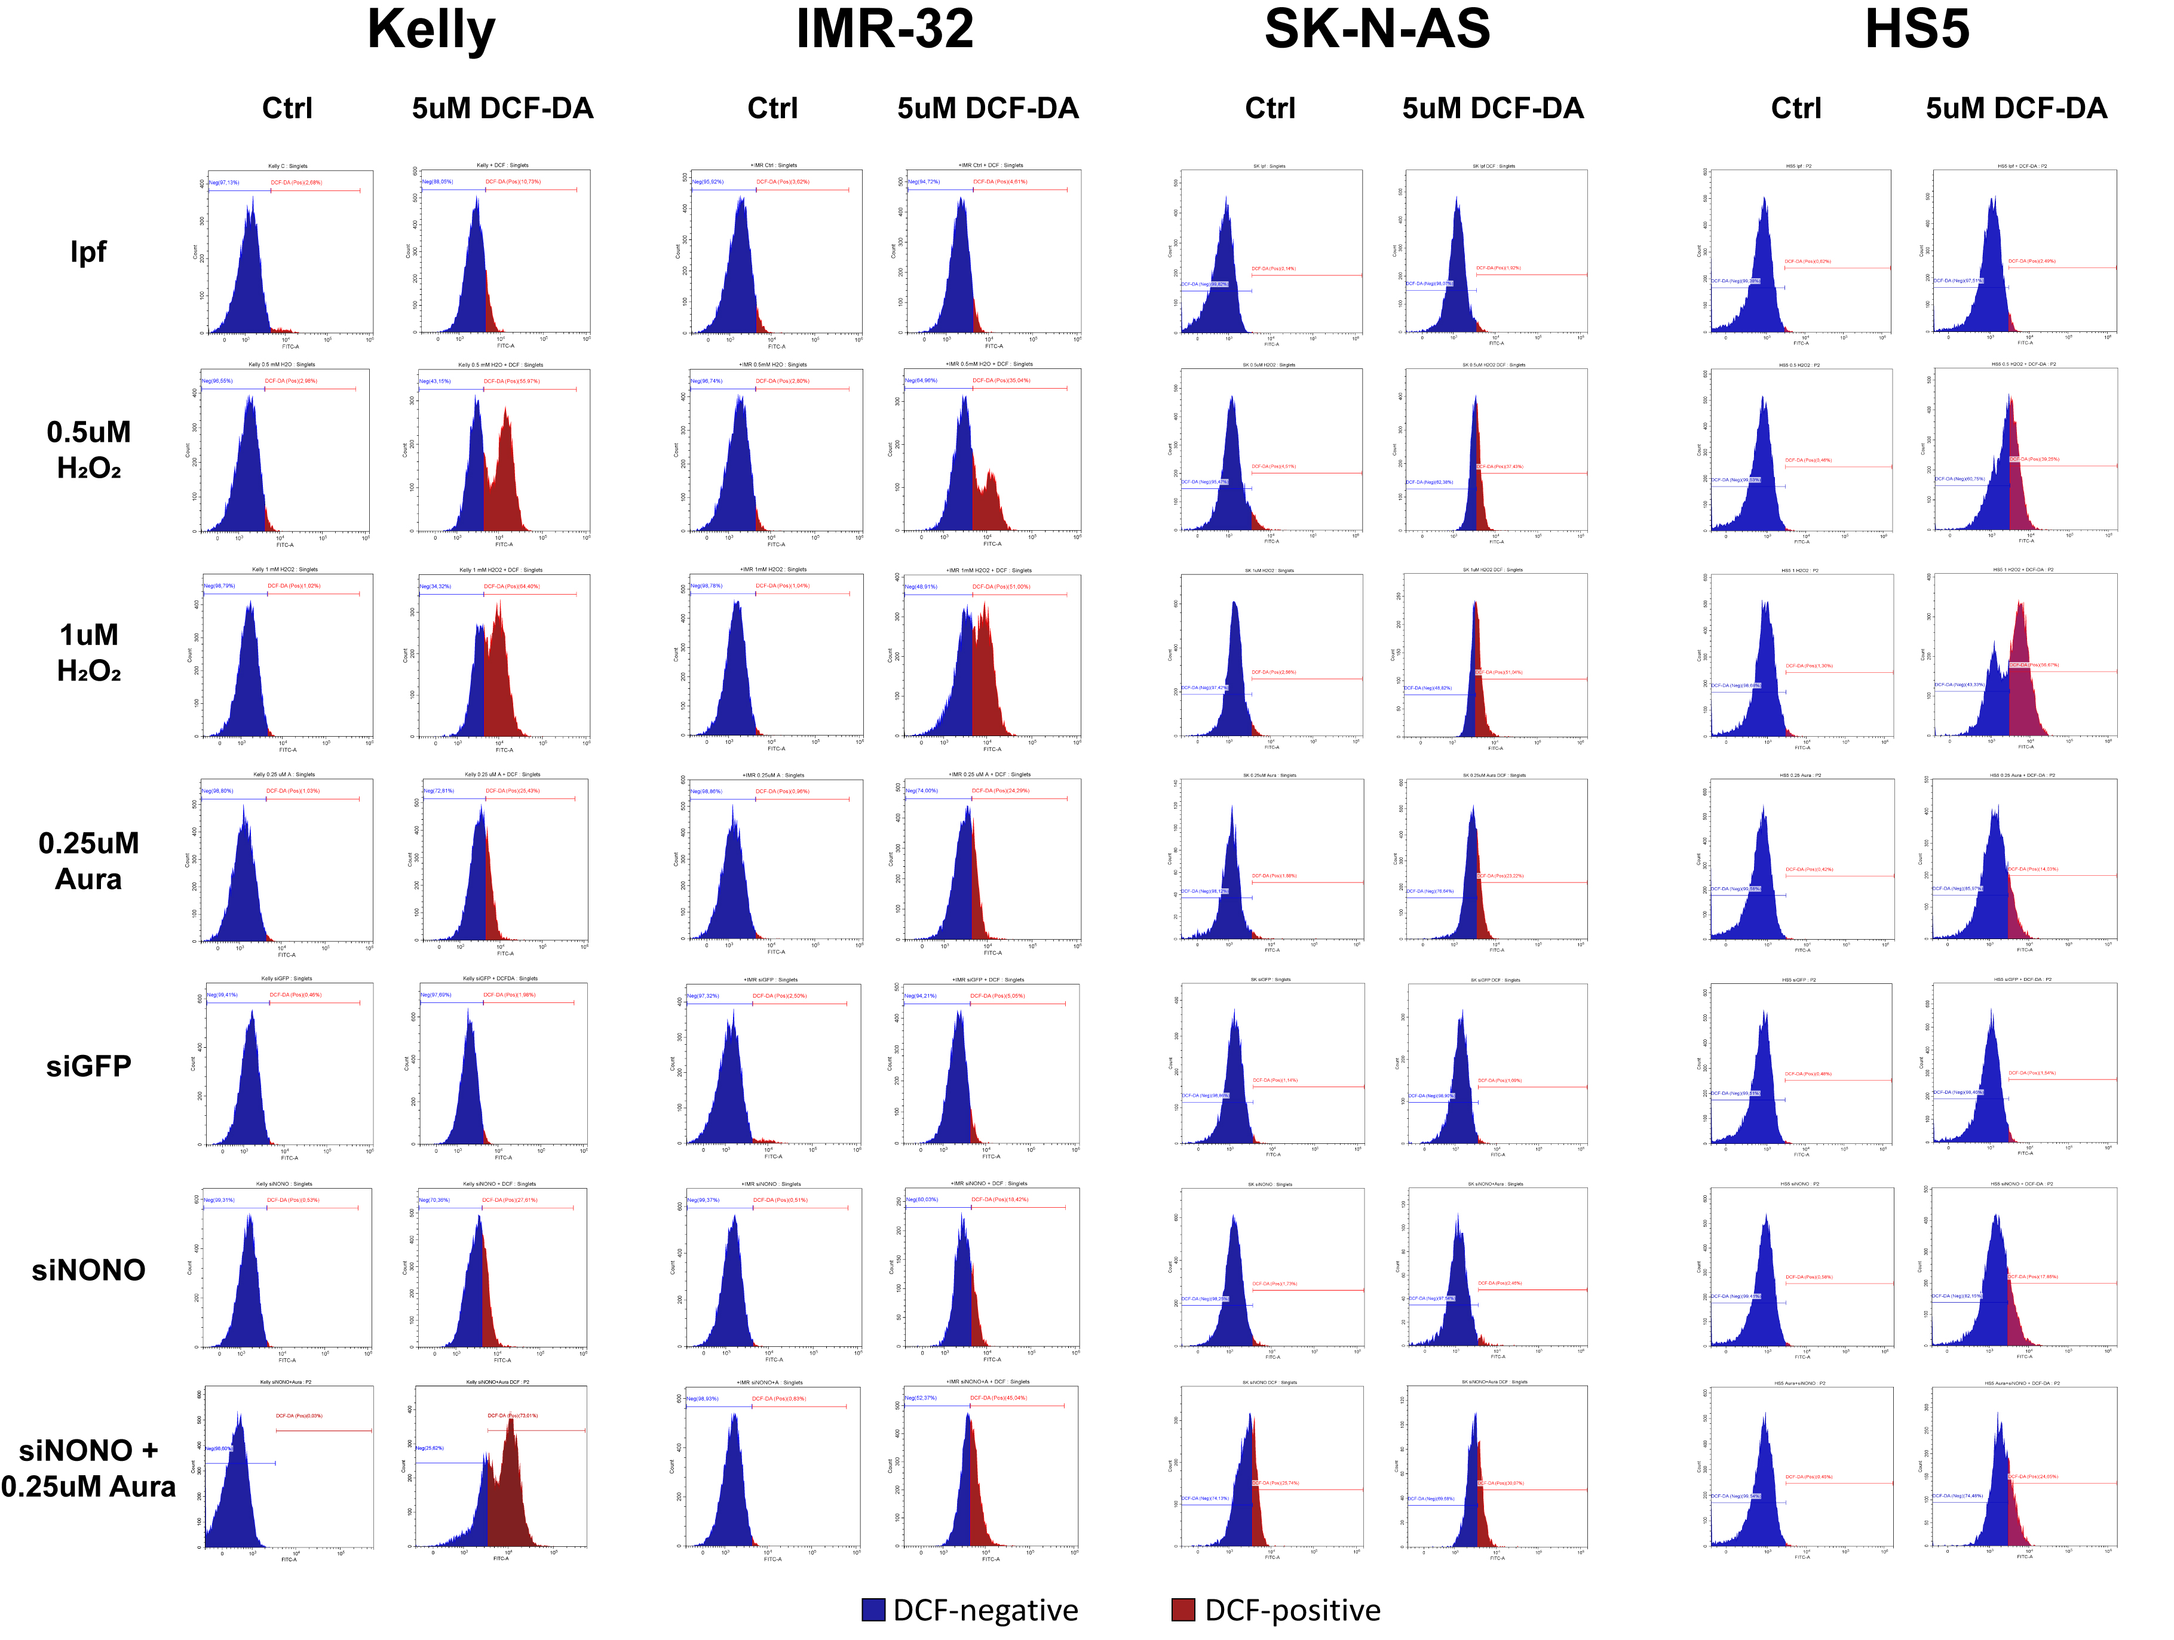
Supplementary Fig. 1. Flow cytometry-assisted analysis of auranofin cytotoxicity. Cell cycle distribution after 2-24 h auranofin treatment of 3 NB and 1 fibroblast cell lines. See Materials and Methods for details.

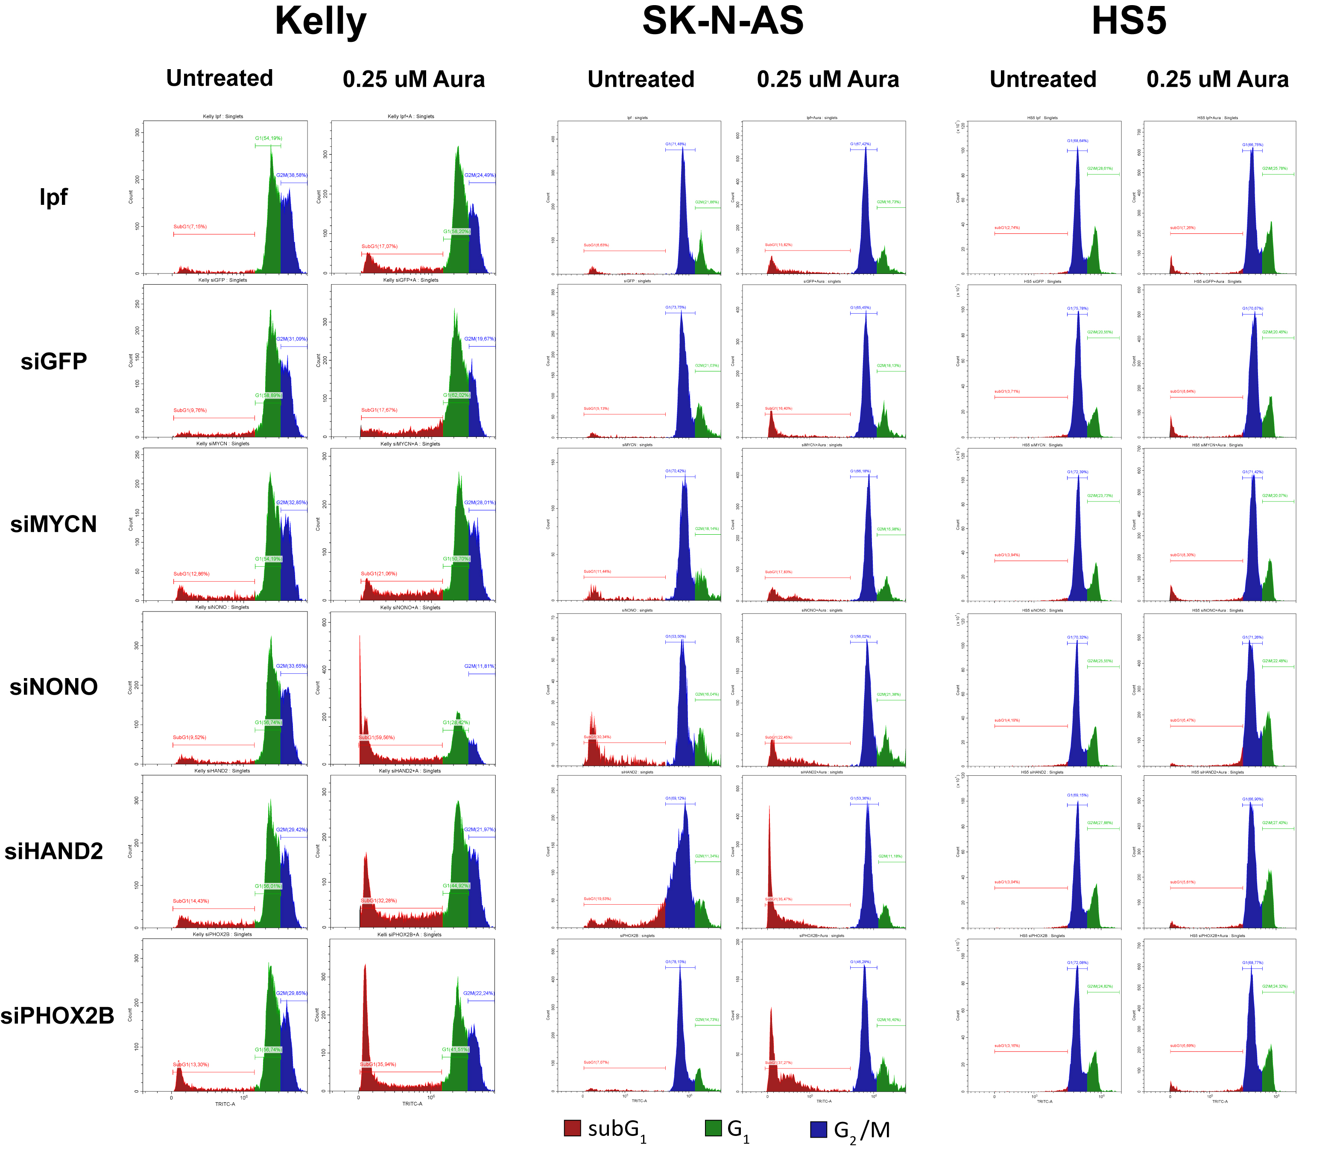
Supplementary Fig. 2. Cell cycle distribution in response to combinations of individual gene knockdown and auranofin. See Materials and Methods for details.

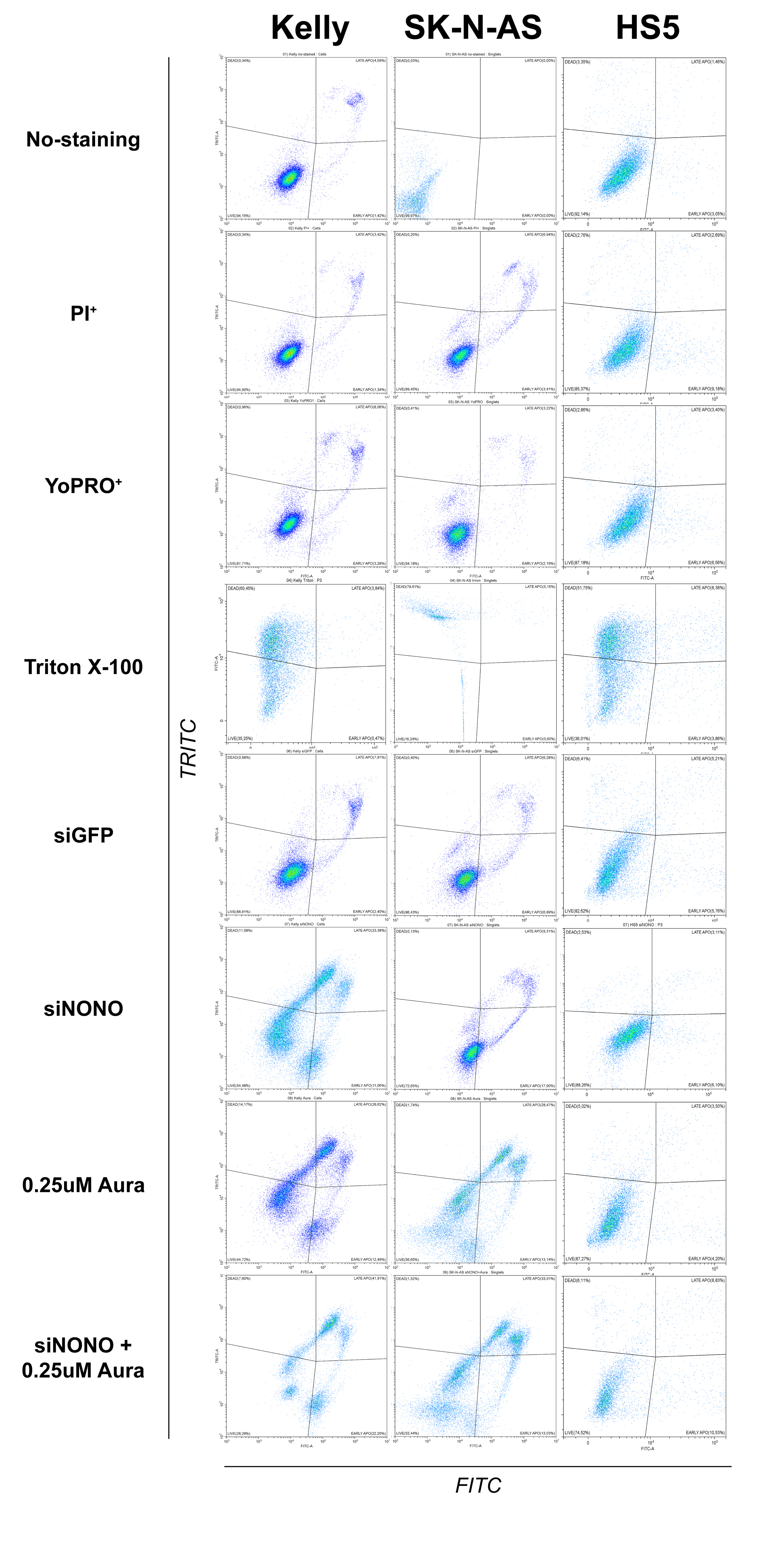
Supplementary Fig. 3. Histograms of cell staining with PI and YO-PRO™-1 after treatment with siRNA and auranofin. See Materials and Methods for details.

Supplementary Fig. 4. Intracellular ROS content (DCFH₂-DA fluorescence assays). See Materials and Methods for details.

